OS Assignment-11

Jeetu Mehra
U24AI032

1. Implementation of resource allocation graph (RAG), where a number of processes, resources exit in the state of a system.
#include <stdio.h>
#define MAX 20

int graph[MAX][MAX]; // Adjacency matrix int visited[MAX], recStack[MAX]; int n; // total nodes (processes + resources)

// Function to add edge void addEdge(int u, int v) { graph[u][v] = 1;
}

// DFS for cycle detection int isCyclicUtil(int v) { visited[v] = 1; recStack[v] = 1;

for (int i = 0; i < n; i++) { if (graph[v][i]) { if (!visited[i] && isCyclicUtil(i)) return 1; else if (recStack[i]) return 1;
}
}

recStack[v] = 0; return 0;
}

// Check deadlock (cycle in RAG) int isDeadlock() { for (int i = 0; i < n; i++) { visited[i] = 0; recStack[i] = 0;
}

for (int i = 0; i < n; i++) { if (!visited[i]) { if (isCyclicUtil(i)) return 1;
}
}
return 0;
}

// Display graph void display() { printf("\nAdjacency Matrix:\n");
for (int i = 0; i < n; i++) { for (int j = 0; j < n; j++) { printf("%d ", graph[i][j]);
}
printf("\n");
}
}

int main() {
int p, r; int u, v, choice;

printf("Enter number of processes: "); scanf("%d", &p);

printf("Enter number of resources: "); scanf("%d", &r);

n = p + r; // total nodes

// Initialize graph for (int i = 0; i < n; i++) for (int j = 0; j < n; j++) graph[i][j] = 0;

do {
printf("\n1. Add Request Edge (Process -> Resource)"); printf("\n2. Add Allocation Edge (Resource -> Process)"); printf("\n3. Display Graph"); printf("\n4. Check Deadlock"); printf("\n5. Exit"); printf("\nEnter choice: "); scanf("%d", &choice);

switch (choice) { case 1:
printf("Enter Process index (0 to %d): ", p - 1); scanf("%d", &u); printf("Enter Resource index (0 to %d): ", r - 1); scanf("%d", &v); addEdge(u, p + v); // process -> resource
break;

case 2:
printf("Enter Resource index (0 to %d): ", r - 1); scanf("%d", &u); printf("Enter Process index (0 to %d): ", p - 1); scanf("%d", &v); addEdge(p + u, v); // resource -> process
break;

case 3: display(); break;

case 4:
if (isDeadlock()) printf("\nDeadlock Detected!\n");
else
printf("\nNo Deadlock.\n"); break;

case 5: break;

default:
printf("Invalid choice!\n");
}

} while (choice != 5);

return 0;
}
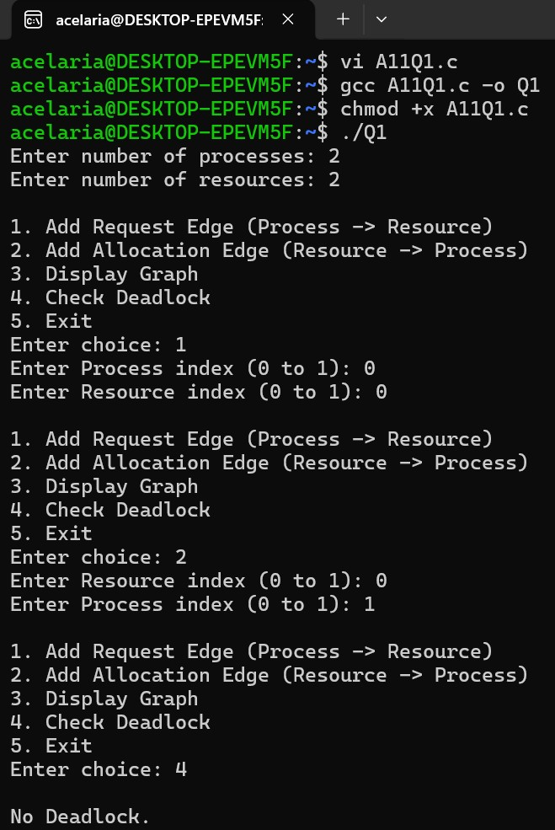
2. Consider a state of system where there are number of process, number of resources. A process is requesting resource. Consider a scenario of a resource allocation graph or wait for graph with cycle and without cycle. Implement Cycle Detection Algorithm (DFS-based) in RAG to check for deadlock.
#include <stdio.h>

#define MAX 20

int graph[MAX][MAX]; int visited[MAX], recStack[MAX]; int n; // total nodes

// Add edge void addEdge(int u, int v) { graph[u][v] = 1;
}

// DFS for cycle detection int dfs(int v) { visited[v] = 1; recStack[v] = 1;

for (int i = 0; i < n; i++) { if (graph[v][i]) { if (!visited[i] && dfs(i)) return 1; else if (recStack[i]) return 1;
}
}

recStack[v] = 0; return 0;
}

// Check deadlock int detectCycle() { for (int i = 0; i < n; i++) { visited[i] = 0; recStack[i] = 0;
}

for (int i = 0; i < n; i++) { if (!visited[i]) { if (dfs(i)) return 1;
}
}
return 0;
}

// Display graph void display() { printf("\nAdjacency Matrix:\n");
for (int i = 0; i < n; i++) { for (int j = 0; j < n; j++) { printf("%d ", graph[i][j]);
}
printf("\n");
}
}

int main() { int p, r, choice, u, v;

printf("Enter number of processes: "); scanf("%d", &p);

printf("Enter number of resources: "); scanf("%d", &r);

n = p + r;

// Initialize graph for (int i = 0; i < n; i++) for (int j = 0; j < n; j++) graph[i][j] = 0;

do { printf("\n1. Add Request Edge (P -> R)"); printf("\n2. Add Allocation Edge (R -> P)"); printf("\n3. Display Graph"); printf("\n4. Check Deadlock"); printf("\n5. Exit"); printf("\nEnter choice: "); scanf("%d", &choice);

switch (choice) { case 1:
printf("Enter Process (0 to %d): ", p-1); scanf("%d", &u); printf("Enter Resource (0 to %d): ", r-1); scanf("%d", &v); addEdge(u, p + v); break;

case 2:
printf("Enter Resource (0 to %d): ", r-1); scanf("%d", &u); printf("Enter Process (0 to %d): ", p-1); scanf("%d", &v); addEdge(p + u, v); break;

case 3: display(); break;

case 4:
if (detectCycle()) printf("\nDeadlock Detected (Cycle Found)\n");
else
printf("\nNo Deadlock (No Cycle)\n");
break;

}
} while (choice != 5);

return 0;
}
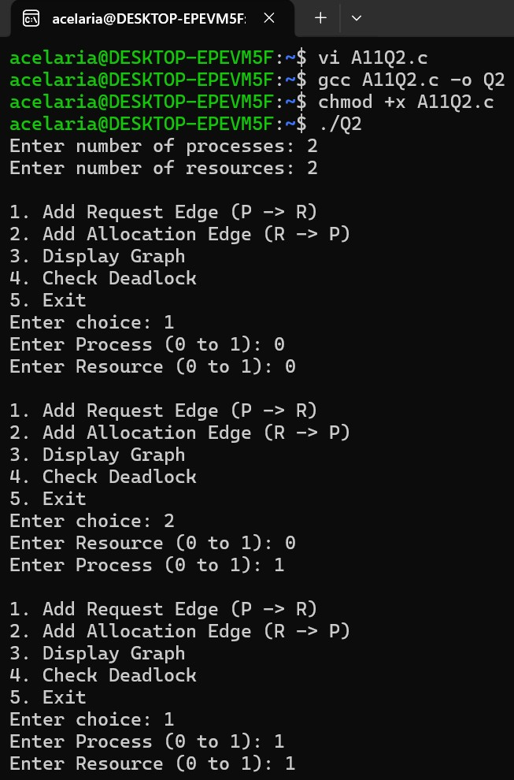
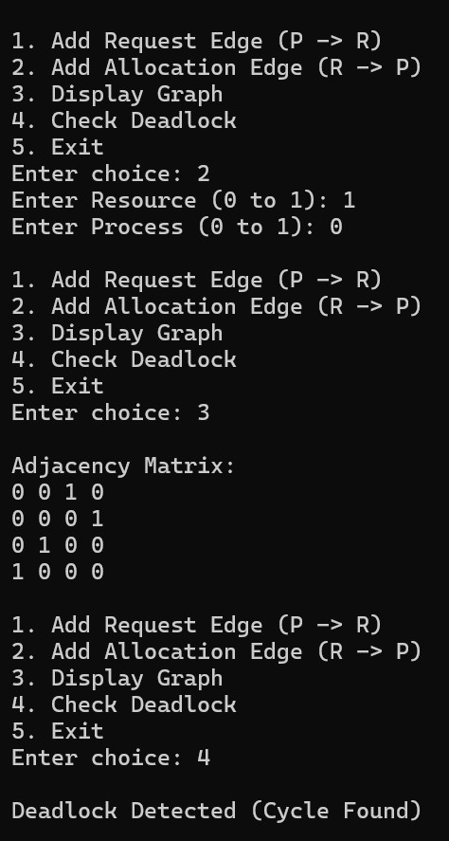
3. Write a program to implement a way to prevent runtime a possibility of a deadlock occurring in a system described as follows
Write a program with following specifications:
Command line input: name of a file
- The file contains the initial state of the system as given below (example included in right column) #no of resources 4
#no of instances of each resource 2 4 5 3
#no of processes 3
#no of instances of each resource that 1 1 1 1, 2 3 1 2, 2 2 1 3 each processes needs in its lifetime.
The rule is that once a process uses a resource instance and returns it, the process no more needs it. For example, in the above set of 3 processes, If P2 finishes with 1 instance of resource r3, it will only need 3-1=2 instances of r3 in future. A process completes immediately when its need eventually reduces to 0.
Read this in
The programs then waits to accept a resource allocation or release requests-this is supplied through keyboard
For example:
0 a 1 0 1 1 indicates that p0 has requested allocation of 1 instance of R0, R2 and R3 each. or
3 r 0 0 0 3 indicates that p3 is releasing 3 instances of resource r3
Your program should declare the result:
- should this request be granted? (i.e. guaranteeing that there will be no deadlock in future considering a worst remaining demand for resources)

- if your answer is yes, print the safe sequence in which all remaining needs can be granted one by one and also grant the request, making necessary changes to system's state. If the requesting process's need is NIL, the program internally releases all its resources.
Go back to accept another request till all processes finish with all their needs.
#include <stdio.h>
#include <stdlib.h>

#define MAX 10

int n, m; // n = processes, m = resources

int Available[MAX]; int Max[MAX][MAX]; int Allocation[MAX][MAX]; int Need[MAX][MAX];

// Function to calculate Need matrix void calculateNeed() {
for (int i = 0; i < n; i++) for (int j = 0; j < m; j++)
Need[i][j] = Max[i][j] - Allocation[i][j];
}

// Safety Algorithm int isSafe() { int work[MAX], finish[MAX] = {0}, safeSeq[MAX]; int count = 0;

for (int i = 0; i < m; i++) work[i] = Available[i];

while (count < n) { int found = 0; for (int i = 0; i < n; i++) { if (!finish[i]) { int j; for (j = 0; j < m; j++) { if (Need[i][j] > work[j]) break;
} if (j == m) { for (int k = 0; k < m; k++) work[k] += Allocation[i][k];

safeSeq[count++] = i; finish[i] = 1; found = 1;
}
}
}

if (!found) return 0;
}

printf("Safe Sequence: "); for (int i = 0; i < n; i++) printf("P%d ", safeSeq[i]); printf("\n");

return 1;
}

// Request resources void requestResources(int p, int req[]) {

// Check if request <= Need for (int i = 0; i < m; i++) { if (req[i] > Need[p][i]) { printf("Error: Request exceeds need!\n");
return;
}
}

// Check if request <= Available for (int i = 0; i < m; i++) { if (req[i] > Available[i]) { printf("Resources not available!\n");
return;
}
}

// Pretend allocation for (int i = 0; i < m; i++) { Available[i] -= req[i];
Allocation[p][i] += req[i];
Need[p][i] -= req[i];
}

// Check safety if (isSafe()) { printf("Request Granted!\n");
} else {
printf("Request Denied (Unsafe State)\n");

// Rollback for (int i = 0; i < m; i++) { Available[i] += req[i];
Allocation[p][i] -= req[i];
Need[p][i] += req[i];
}
}
}

// Release resources void releaseResources(int p, int rel[]) { for (int i = 0; i < m; i++) { if (rel[i] > Allocation[p][i]) { printf("Error: Cannot release more than allocated!\n");
return;
}

Available[i] += rel[i];
Allocation[p][i] -= rel[i];
Need[p][i] += rel[i];
}

printf("Resources Released!\n");
}

// Read file void readFile(char *filename) {
FILE *fp = fopen(filename, "r");

fscanf(fp, "%d", &m); // resources for (int i = 0; i < m; i++) fscanf(fp, "%d", &Available[i]);

fscanf(fp, "%d", &n); // processes

for (int i = 0; i < n; i++) for (int j = 0; j < m; j++) fscanf(fp, "%d", &Max[i][j]);

// Initially allocation = 0 for (int i = 0; i < n; i++) for (int j = 0; j < m; j++)
Allocation[i][j] = 0;

calculateNeed();
}

int main(int argc, char *argv[]) {

if (argc < 2) { printf("Usage: ./a.out input.txt\n"); return 0;
}

readFile(argv[1]);

while (1) { int p; char type; int arr[MAX];

printf("\nEnter request/release (e.g., 0 a 1 0 1 1 OR 1 r 0 0 0 2):\n");

scanf("%d %c", &p, &type);

for (int i = 0; i < m; i++) scanf("%d", &arr[i]);

if (type == 'a') { requestResources(p, arr); } else if (type == 'r') { releaseResources(p, arr);
}

// Check if process finished int done = 1; for (int i = 0; i < m; i++) { if (Need[p][i] != 0) done = 0;
}

if (done) { printf("Process P%d completed, releasing all resources\n", p); for (int i = 0; i < m; i++) {
Available[i] += Allocation[p][i];
Allocation[p][i] = 0;
}
}
}

return 0;
}
Input.txt
4
2 4 5 3 3
- 1 1 1
- 3 1 2
2 2 1 3
